NAME: SNEHA TIWARI
UNIV. ROLL NO.: 11500119052
ASSIGNMENT – 1 (PCC-CS692)
1. Print Own Machine IP Address.
import java.net.*;
public class INET
{
public static void main(String args[])throws UnknownHostException
{
try{
InetAddress IPO = InetAddress.getLocalHost();
System.out.println("IP address of the system = " + IPO.getHostAddress());
}
catch(Exception exp){
System.out.println("Address could not be fetched!\n " + exp.getMessage());
}
}
}
OUTPUT

2. Print Remote Machine/Website IP Address.
import java.net.*;
import java.*;
public class remoteIP{
public static void main(String args[])
throws UnknownHostException
{
String s = "https://www.google.com/";
try {
InetAddress ip = InetAddress.getByName(new URL(s).getHost());
System.out.println("Public IP Address of: "+ip);
}
catch (MalformedURLException e) {
System.out.println("Invalid URL!");
}
}
}

OUTPUT

3. Network Commands

NAME: SNEHA TIWARI
UNIV. ROLL NO.: 11500119052
ASSIGNMENT – 2 (PCC-CS692)
1. Implement Ping (Remote/Own) program.
import java.io.*;
import java.net.*;
import java.util.*;
class Ping
{
public static void sendPingRequest(String ipAddress) throws UnknownHostException,
IOException
{
InetAddress ipo = InetAddress.getByName(ipAddress);
System.out.println("\nSending Ping Request to " + ipAddress);
if(ipo.isReachable(5000))
System.out.println("Host is reachable.");
else
System.out.println("Host unreachable!!!");
}
public static void main(String[] args) throws UnknownHostException, IOException
{
Scanner sc = new Scanner(System.in);
System.out.println("Enter IP Address: ");
String inp_address = sc.nextLine();
sendPingRequest(inp_address);
}
}
OUTPUT
2. Implement Port Scanner program.
import java.io.*;
import java.net.*;
import java.util.*;
class PortScanner
{
public static void main(String args[]) throws Exception
{
int startPort = 0;
int stopPort = 60;
int count = 1;
int n1 = 0;
int n2 = 0;
Scanner sc = new Scanner(System.in);
System.out.println("Enter Socket Address: ");
String input = sc.nextLine();
for(int i=startPort; i<=stopPort; i++)
{
try
{
Socket s = new Socket(input, i);
System.out.println("\nPort in use: " + count);
count = count+1;
n1 = n1+1;
s.close();
}
catch(Exception e)
{
System.out.println("\nException caught: " + e.getMessage());
if(count != 0){
System.out.println("Port not in use: " + count);
count = count+1;
n2 = n2+1;
}
}
}
System.out.println("\nTotal ports in use: "+n1+"\nTotal ports not in use: "+n2);
}
}
OUTPUT

NAME: SNEHA TIWARI
ROLL NO.: 11500119052

ASSIGNMENT 3: Connection oriented TCP socket programming (Two Way Communication)

Client Side: myChatClient.java
import java.io.IOException;
import java.io.PrintStream;
import java.net.Socket;
import java.net.UnknownHostException;
import java.util.Scanner;
public class myChatClient {
public static void main(String arg[]) throws UnknownHostException,IOException
{
String number,temp;
Scanner sc = new Scanner(System.in);
Socket s=new Socket("127.0.0.1",1408);
Scanner sc1=new Scanner(s.getInputStream());
System.out.println("Send any message: ");
number=sc.nextLine();
PrintStream p=new PrintStream(s.getOutputStream());
p.println(number);
temp=sc1.nextLine();
System.out.println("Message sent by Server: "+temp);
s.close();
sc.close();
}
}

Output:
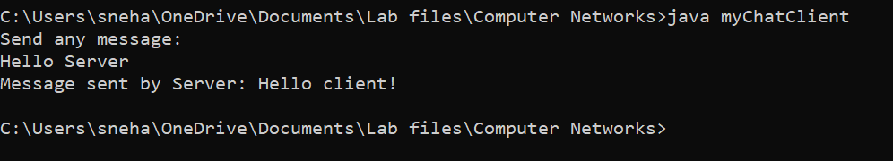
Server Side: myChatServer.java

import java.io.IOException;
import java.io.PrintStream;
import java.net.ServerSocket;
import java.net.Socket;
import java.util.Scanner;

public class myChatServer {
public static void main(String[] args) throws IOException {
String str;
ServerSocket s1=new ServerSocket(1408);
Socket ss=s1.accept();
Scanner sc=new Scanner(ss.getInputStream());
str=sc.nextLine();
PrintStream p=new PrintStream(ss.getOutputStream());
p.println("Hello client!");
System.out.println("Message send by client: "+str);
if(!ss.isClosed())
{
s1.close();
System.out.println("Server closed.");
}
}
}

Output:
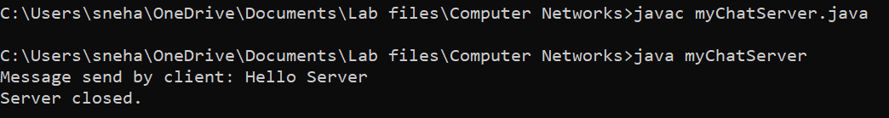
NAME: SNEHA TIWARI
ROLL NO.: 11500119052

ASSIGNMENT 4: Connection oriented UDP socket programming (Two Way Communication) => Chatting + Problem Solving

Client Side: udpClient.java
import java.io.IOException;
import java.net.DatagramPacket;
import java.net.DatagramSocket;
import java.net.InetAddress;
import java.util.Scanner;

public class udpClient {
public static void main(String args[]) throws IOException
{
Scanner sc = new Scanner(System.in);
DatagramSocket ds = new DatagramSocket();
InetAddress ip = InetAddress.getLocalHost();
byte buf[] = null;
byte buf2[] = null;

System.out.println("Enter text: ");
while (true)
{
String inp = sc.nextLine();
buf2 = inp.getBytes();
DatagramPacket DpSend = new DatagramPacket(buf2, buf2.length, ip, 1234);
ds.send(DpSend);
if (inp.equals("Goodbye"))
break;

System.out.print("Enter the equation in the format:");
System.out.println("'operand1 operator operand2'");
inp = sc.nextLine();
buf = new byte[65535];
buf = inp.getBytes();
DatagramPacket DpSend2 = new DatagramPacket(buf, buf.length, ip, 5678);
ds.send(DpSend2);
buf = new byte[65535];
DatagramPacket DpReceive = new DatagramPacket(buf, buf.length);
ds.receive(DpReceive);
System.out.println("Answer: " + new String(buf, 0, buf.length));
}
sc.close();
ds.close();
}
}
Output:
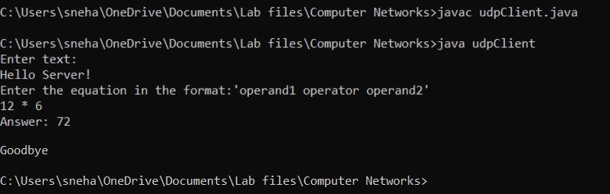
Server Side: udpServer.java
import java.io.IOException;
import java.net.DatagramPacket;
import java.net.DatagramSocket;
import java.net.InetAddress;
import java.lang.StringBuilder;
import java.util.StringTokenizer;

class udpServer {
public static void main(String[] args) throws IOException {
DatagramSocket ds = new DatagramSocket(1234);
byte[] buf = null;
DatagramPacket DpReceive = null;
DatagramPacket DpSend = null;

DatagramSocket ds2 = new DatagramSocket(5678);
byte[] receive = new byte[65535];

DatagramPacket DpReceive2 = null;
while (true) {
DpReceive = new DatagramPacket(receive, receive.length);
ds.receive(DpReceive);

System.out.println("Client says: " + data(receive));
if (data(receive).toString().equals("Goodbye"))
{
System.out.println("\nClient sent Goodbye.\nExiting....");
break;
}

receive = new byte[65535];
buf = new byte[65535];
DpReceive2 = new DatagramPacket(buf, buf.length);
ds2.receive(DpReceive2);

String inp = new String(buf, 0, buf.length);
inp = inp.trim();

System.out.println("Equation Received: " + inp);
int result;
StringTokenizer st = new StringTokenizer(inp);
if (inp.equals("Goodbye")) {
System.out.println("\nClient sent Goodbye.\nExiting....");
break;
}

int oprnd1 = Integer.parseInt(st.nextToken());
String operation = st.nextToken();
int oprnd2 = Integer.parseInt(st.nextToken());
if (operation.equals("+"))
result = oprnd1 + oprnd2;

else if (operation.equals("-"))
result = oprnd1 - oprnd2;

else if (operation.equals("*"))
result = oprnd1 * oprnd2;
else
result = oprnd1 / oprnd2;

System.out.println("Sending the result...");
String res = Integer.toString(result);
buf = res.getBytes();
int port = DpReceive.getPort();
DpSend = new DatagramPacket(buf, buf.length, InetAddress.getLocalHost(), port);
ds2.send(DpSend);
}
ds2.close();
ds.close();
}
public static StringBuilder data(byte[] a) {
if (a == null)
return null;
StringBuilder ret = new StringBuilder();
int i = 0;
while (a[i] != 0) {
ret.append((char) a[i]);
i++;
}
return ret;
}

}

Output:
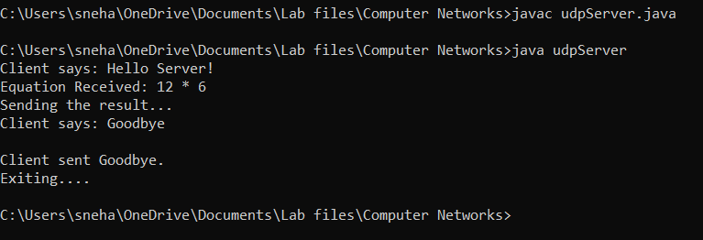

NAME: SNEHA TIWARI
ROLL NO.: 11500119052

ASSIGNMENT 5: Multicast between 2 computers (Sender & Receiver)

Sender.java

package Assignment5_11500119052;
import java.util.*;
import java.net.*;

class Sender {
public static void main(String[] agrs) throws Exception {
Scanner sc = new Scanner(System.in);
DatagramSocket ds = new DatagramSocket();
InetAddress ip = InetAddress.getByName("225.0.0.4");
MulticastSocket ms = new MulticastSocket(4002);
System.out.println("Enter your cast message: ");
String msg = sc.nextLine();
DatagramPacket dp = new DatagramPacket(msg.getBytes(), msg.length(), ip, 4002);
ds.send(dp);
sc.close();
ms.close();
ds.close();
}
}

Output:

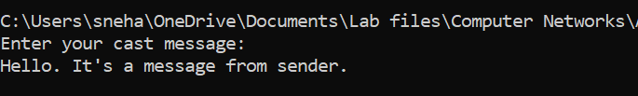

Receiver.java

package Assignment5_11500119052;
import java.net.*;

class Receiver {
public static void main(String[] args) throws Exception {
InetAddress mcastaddr = InetAddress.getByName("225.0.0.4");
NetworkInterface netIf = NetworkInterface.getByName("bge0");
MulticastSocket ms = new MulticastSocket(4002);

ms.joinGroup(new InetSocketAddress(mcastaddr, 0), netIf);
byte[] b = new byte[1200];
DatagramPacket dp = new DatagramPacket(b, b.length);
ms.receive(dp);
String str = new String(dp.getData());
System.out.println("Cast message: " + str);
ms.close();
}
}

Output:

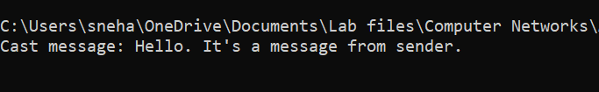

NAME: SNEHA TIWARI
UNIV. ROLL NO.: 11500119052
ASSIGNMENT6 - CRC

Sender.java
import java.io.*;
import java.net.*;
import java.util.*;
public class Sender{
Socket requestSocket;
ObjectOutputStream out;
ObjectInputStream in;
String message;
boolean check=true;
Sender(){}
void run()
{
try{
Scanner sc = new Scanner(System.in);
BufferedReader br=new BufferedReader(new InputStreamReader(System.in));
requestSocket = new Socket("localhost", 1234);
System.out.println("\nConnected to localhost in port 1234...");
out = new ObjectOutputStream(requestSocket.getOutputStream());
out.flush();
in = new ObjectInputStream(requestSocket.getInputStream());
message = (String)in.readObject();
System.out.println("Server: " + message);

do{
try{
System.out.println("Enter data bits to send: ");
message = br.readLine();
if(checkbinary(message)){
check=false;
System.out.println("\nChecksum generated: "+checksum(message.concat("000")) );
System.out.println("Enter the data along with checksum appended: ");
String data = sc.nextLine();
message=message.concat(checksum(message.concat("000")));
sendMessage(data);
}
else{
System.out.println("Entered data is not in binary format." );
}
}
catch(Exception classNot){
System.err.println("Data received in unknown format: "+classNot);
}
}
while(check);
try{
System.out.println("Data sent!\n" );
message = (String)in.readObject();
System.out.println("Server: " + message);
}
catch(Exception e){}

}
catch(UnknownHostException unknownHost){
System.err.println("\nYou are trying to connect to an unknown host!");
}
catch(IOException ioException){
ioException.printStackTrace();
}
catch(Exception e){}
finally{
try{
in.close();
out.close();
requestSocket.close();
}
catch(IOException ioException){
ioException.printStackTrace();
}
}
}
boolean checkbinary(String str){
int n=Integer.valueOf(str);
int len=str.length();
int sum=0;
for(int i=0;i<len;i++){
sum=n%10;
if(sum>1) return false;
}
return true;

}
String checksum(String str){
int[] a=new int[20];
int n=str.length();
for(int i=0;i<n;i++){
a[i]=Integer.valueOf(str.substring(i,i+1));
}
for(int i=0;i<n-3;i++){
if(a[i]==1){
a[i]=(a[i]==1)?0:1;
a[i+1]=(a[i+1]==1)?1:0;
a[i+2]=(a[i+2]==1)?0:1;
a[i+3]=(a[i+3]==1)?0:1;
}
}
str=String.valueOf(a[n-3]);
str=str.concat(String.valueOf(a[n-2]));
str=str.concat(String.valueOf(a[n-1]));

return str;
}
void sendMessage(String msg)
{
try{
out.writeObject(msg);
out.flush();
System.out.println("Client: " + msg);
}
catch(IOException ioException){
ioException.printStackTrace();
}
}
public static void main(String args[])
{
Sender client = new Sender();
client.run();
}
}

Receiver.java

import java.io.*;
import java.net.*;
public class Reciever{
ServerSocket RecieverSocket;
Socket connection = null;
ObjectOutputStream out;
ObjectInputStream in;
String message,checksum;
Reciever(){}
void run()
{
try{
BufferedReader br=new BufferedReader(new InputStreamReader(System.in));
RecieverSocket = new ServerSocket(1234, 20);
System.out.println("Waiting for connection...");
connection = RecieverSocket.accept();
System.out.println("Connection received from: " + connection.getInetAddress().getHostName());
out = new ObjectOutputStream(connection.getOutputStream());
out.flush();
in = new ObjectInputStream(connection.getInputStream());
sendMessage("Connection successful ...");
try{
message = (String)in.readObject();
System.out.println("Client: " + message);
checksum=checksum(message);
message=(checksum.equals("000"))?"Your data is CORRECT!!":"Oops.. Your data is Corrupted!!";
sendMessage(message);
}
catch(ClassNotFoundException classnot){
System.err.println("Data received in unknown format.");
}
}
catch(IOException ioException){
ioException.printStackTrace();
}
finally{
try{
in.close();
out.close();
RecieverSocket.close();
}
catch(IOException ioException){
ioException.printStackTrace();
}
}
}
String checksum(String str){
int[] a=new int[20];
int n=str.length();
for(int i=0;i<n;i++){
a[i]=Integer.valueOf(str.substring(i,i+1));
}

//Generator is 1011

for(int i=0;i<n-3;i++){ //xor operation with 1011
if(a[i]==1){
a[i]=(a[i]==1)?0:1;
a[i+1]=(a[i+1]==1)?1:0;
a[i+2]=(a[i+2]==1)?0:1;
a[i+3]=(a[i+3]==1)?0:1;
}
}
str=String.valueOf(a[n-3]);
str=str.concat(String.valueOf(a[n-2]));
str=str.concat(String.valueOf(a[n-1]));
return str;
}
void sendMessage(String msg)
{
try{
out.writeObject(msg);
out.flush();
System.out.println("Server: " + msg);
}
catch(IOException ioException){
ioException.printStackTrace();
}
}
public static void main(String args[])
{
Reciever server = new Reciever();
while(true){
server.run();
}
}
}

OUTPUT:

- WITHOUT ERROR

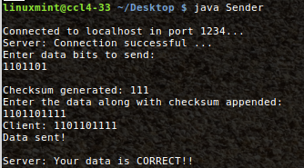

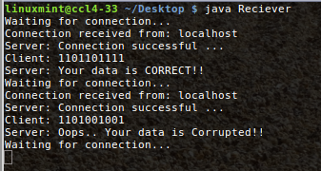

- WITH ERROR

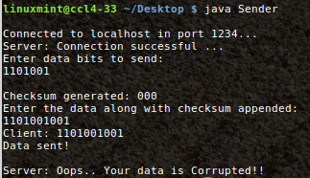

NAME: SNEHA TIWARI
ROLL NO.: 11500119052

ASSIGNMENT 8: STOP AND WAIT

Sender.java:
package Assignment8;
import java.io.*;
import java.net.*;
import java.util.*;

public class Sender{
public static void main(String args[]) throws Exception{
Sender sws = new Sender();
sws.run();
}
public void run() throws Exception{
Scanner sc=new Scanner(System.in);
System.out.println("Enter no. of frames to be sent: ");
int n=sc.nextInt();
Socket myskt = new Socket("localhost",4444);
PrintStream myps = new PrintStream(myskt.getOutputStream());
for(int i=0;i<=n;){
if(i==n){
myps.println("exit");
break;
}
System.out.println("Frame no. "+ i +" has been sent.");
myps.println(i);

BufferedReader bf = new BufferedReader(new InputStreamReader(myskt.getInputStream()));
String ack = bf.readLine();
if(ack!=null){
System.out.println("Acknowledgement Received!\n");
i++;
Thread.sleep(4000);
}
else{
myps.println(i);
}
}
myskt.close();
sc.close();
}

Receiver.java:
package Assignment8;
import java.io.*;
import java.net.*;

public class Receiver{
public static void main(String args[])throws Exception{
Receiver swr = new Receiver();
swr.run();
}

public void run() throws Exception{
String temp ="Any message",str="exit";
ServerSocket myss =new ServerSocket(4444);
Socket ss_accept = myss.accept();
BufferedReader ss_bf = new BufferedReader(new InputStreamReader(ss_accept.getInputStream()));

PrintStream myps = new PrintStream(ss_accept.getOutputStream());

while(temp.compareTo(str)!=0){
Thread.sleep(1000);
temp = ss_bf.readLine();
if(temp.compareTo(str)==0){
break;
}
System.out.println("Frame "+temp+" was received.");
Thread.sleep(500);
myps.println("Received");
}
System.out.println("All Frames were received SUCCESSFULLY !!");
myss.close();
}
}

Output:
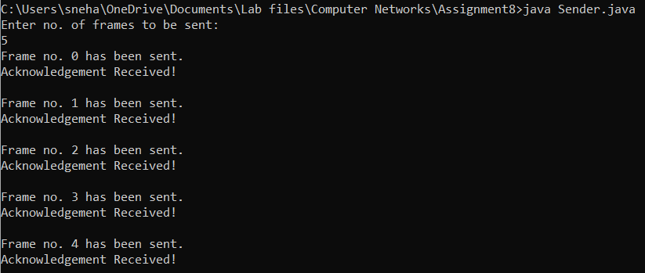
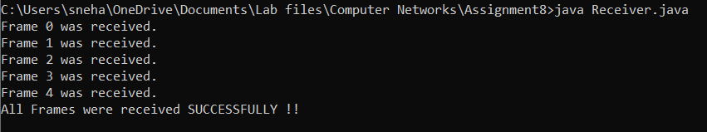
NAME: SNEHA TIWARI
UNIV.ROLL NO.: 11500119052
ASSIGNMENT 9: HAMMING CODE

import java.util.*;
class HammingCodeExample {
public static void main(String args[])
{
int size, hammingCodeSize, errorPosition;
int arr[];
int hammingCode[];
Scanner sc = new Scanner(System.in);
System.out.println("Enter the size for the data: ");
size = sc.nextInt();
arr = new int[size];
for(int j = 0 ; j < size ; j++) {
System.out.println("Enter data bit-" + (size - j) + ": ");
arr[size - j - 1] = sc.nextInt();
}
System.out.println("\nThe data which you enter is: ");
for(int k = 0 ; k < size ; k++) {
System.out.print(arr[size - k - 1]);
}
System.out.println();
hammingCode = getHammingCode(arr);
hammingCodeSize = hammingCode.length;

System.out.println("\nThe hamming code generated for your data is: ");
for(int i = 0 ; i < hammingCodeSize; i++) {
System.out.print(hammingCode[(hammingCodeSize - i - 1)]);
}
System.out.println();
System.out.println("\nFor detecting error at the receiver end, enter position of a bit to alter original data: "
+ "(0 for no error):");
errorPosition = sc.nextInt();
sc.close();
if(errorPosition != 0) {
hammingCode[errorPosition - 1] = (hammingCode[errorPosition - 1] + 1) % 2;
}

// print sent data to the receiver
System.out.println("\nSent Data is:");
for(int k = 0; k < hammingCodeSize; k++) {
System.out.print(hammingCode[hammingCodeSize - k - 1]);
}
System.out.println(); // for next line
receiveData(hammingCode, hammingCodeSize - arr.length);
}
// create getHammingCode() method that returns the hamming code for the data which we want to send
static int[] getHammingCode(int data[]) {
// declare an array that will store the hamming code for the data
int returnData[];
int size;
// code to get the required number of parity bits
int i = 0, parityBits = 0 ,j = 0, k = 0;
size = data.length;
while(i < size) {
// 2 power of parity bits must equal to the current position(number of bits traversed + number of parity bits + 1).
if(Math.pow(2, parityBits) == (i + parityBits + 1)) {
parityBits++;
}
else {
i++;
}
}

// the size of the returnData is equal to the size of the original data + the number of parity bits.
returnData = new int[size + parityBits];

// for indicating an unset value in parity bit location, we initialize returnData array with '2'

for(i = 1; i <= returnData.length; i++) {
// condition to find parity bit location
if(Math.pow(2, j) == i) {

returnData[(i - 1)] = 2;
j++;
}
else {
returnData[(k + j)] = data[k++];
}
}
// use for loop to set even parity bits at parity bit locations
for(i = 0; i < parityBits; i++) {

returnData[((int) Math.pow(2, i)) - 1] = getParityBit(returnData, i);
}

return returnData;
}

// create getParityBit() method that return parity bit based on the power
static int getParityBit(int returnData[], int pow) {
int parityBit = 0;
int size = returnData.length;

for(int i = 0; i < size; i++) {

// check whether returnData[i] contains an unset value or not
if(returnData[i] != 2) {

// if not, we save the index in k by increasing 1 in its value

int k = (i + 1);
String str = Integer.toBinaryString(k);

int temp = ((Integer.parseInt(str)) / ((int) Math.pow(10, pow))) % 10;
if(temp == 1) {
if(returnData[i] == 1) {
parityBit = (parityBit + 1) % 2;
}
}
}
}
return parityBit;
}

// create receiveData() method to detect error in the received data
static void receiveData(int data[], int parityBits) {

// declare variable pow, which we use to get the correct bits to check for parity.
int pow;
int size = data.length;
// declare parityArray to store the value of parity check
int parityArray[] = new int[parityBits];
// we use errorLoc string for storing the integer value of the error location.
String errorLoc = new String();
// use for loop to check the parities
for(pow = 0; pow < parityBits; pow++) {
// use for loop to extract the bit from 2^(power)
for(int i = 0; i < size; i++) {
int j = i + 1;
// convert the value of j into binary
String str = Integer.toBinaryString(j);
// find bit by using str
int bit = ((Integer.parseInt(str)) / ((int) Math.pow(10, pow))) % 10;
if(bit == 1) {
if(data[i] == 1) {
parityArray[pow] = (parityArray[pow] + 1) % 2;
}
}
}
errorLoc = parityArray[pow] + errorLoc;
}
// This gives us the parity check equation values.
// Using these values, we will now check if there is a single bit error and then correct it.
// errorLoc provides parity check eq. values which we use to check whether a single bit error is there or not
// if present, we correct it
int finalLoc = Integer.parseInt(errorLoc, 2);
if(finalLoc != 0) {
System.out.println("\nError is found at location " + finalLoc + ".");
data[finalLoc - 1] = (data[finalLoc - 1] + 1) % 2;
System.out.println("After correcting the error, the code is:");
for(int i = 0; i < size; i++) {
System.out.print(data[size - i - 1]);
}
System.out.println();
}
else {
System.out.println("\nThere is no error in the received data.");
}
System.out.println("\nData sent from the sender:");
pow = parityBits - 1;
for(int k = size; k > 0; k--) {
if(Math.pow(2, pow) != k) {
System.out.print(data[k - 1]);
}
else {
// decrement value of pow
pow--;
}
}
System.out.println(); // for next line
} }

OUTPUT:
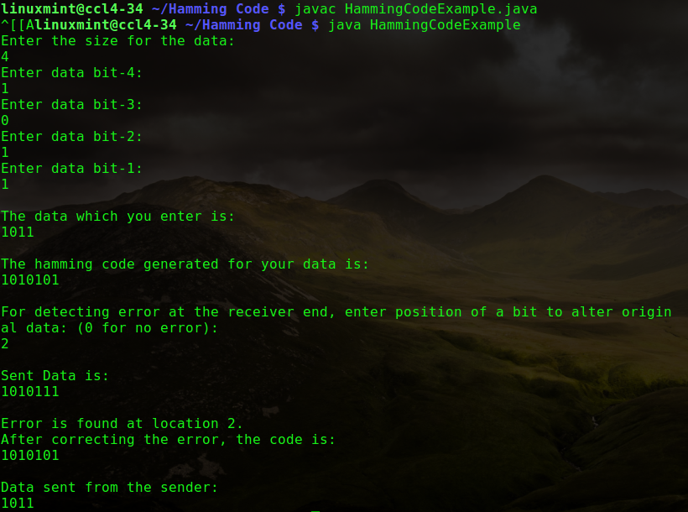

Name: Sneha Tiwari
Univ. Roll No.: 11500119052
Assignment 10 – Concurrent Server

Client Code:

#include <arpa/inet.h>
#include <stdio.h>
#include <string.h>
#include <sys/socket.h>
#include <unistd.h>
#define PORT 8080

int main(int argc, char const* argv[])
{
int sock = 0, valread;
struct sockaddr_in serv_addr;

if ((sock = socket(AF_INET, SOCK_STREAM, 0)) < 0) {
printf("\n Socket creation error \n");
return -1;
}

serv_addr.sin_family = AF_INET;
serv_addr.sin_port = htons(PORT);

if (inet_pton(AF_INET, "127.0.0.1", &serv_addr.sin_addr)<= 0) {
printf("\nInvalid address/ Address not supported \n");
return -1;
}

if (connect(sock, (struct sockaddr*)&serv_addr,sizeof(serv_addr))< 0) {
printf("\nConnection Failed \n");
return -1;
}
for(;;)
{
char hello[1024];
scanf("%[^\n]%*c",hello);
char buffer[1024] = { 0 };
send(sock, hello, strlen(hello), 0);
valread = read(sock, buffer, 1024);
if (strncmp("exit", buffer, 4) == 0) {
printf("Server Exit...\n");
break;
}else
{
printf("Server: %s\n", buffer);
}
}

return 0;
}

Output:
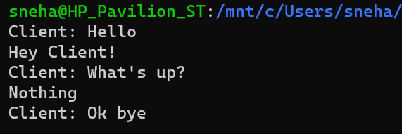

Server Code:

#include <netinet/in.h>
#include <stdio.h>
#include <stdlib.h>
#include <string.h>
#include <sys/socket.h>
#include <unistd.h>
#define PORT 8080
int main(int argc, char const* argv[])
{
int server_fd, new_socket, valread;
struct sockaddr_in address;
int opt = 1;
int addrlen = sizeof(address);

if ((server_fd = socket(AF_INET, SOCK_STREAM, 0))== 0) {
perror("socket failed");
exit(EXIT_FAILURE);
}

if (setsockopt(server_fd, SOL_SOCKET,SO_REUSEADDR | SO_REUSEPORT, &opt,sizeof(opt))) {
perror("setsockopt");
exit(EXIT_FAILURE);
}
address.sin_family = AF_INET;
address.sin_addr.s_addr = INADDR_ANY;
address.sin_port = htons(PORT);

if (bind(server_fd, (struct sockaddr*)&address,sizeof(address))< 0) {
perror("bind failed");
exit(EXIT_FAILURE);
}
if (listen(server_fd, 3) < 0) {
perror("listen");
exit(EXIT_FAILURE);
}
if ((new_socket
= accept(server_fd, (struct sockaddr*)&address,
(socklen_t*)&addrlen))
< 0) {
perror("accept");
exit(EXIT_FAILURE);
}
for(;;)
{

char buffer[1024] = { 0 };
valread = read(new_socket, buffer, 1024);
if (strncmp("exit", buffer, 4) == 0) {
printf("Server Exit...\n");
break;
}else
{
printf("Client: %s\n", buffer);
}
char hello[1024];
scanf("%[^\n]%*c",hello);
send(new_socket, hello, strlen(hello), 0);
}

return 0;
}

Output:
